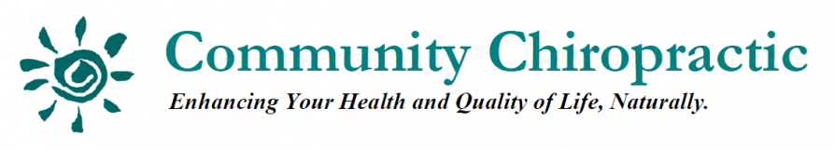
300 Main Street, Groton, MA 01450 978.448.WELL (9355) www.ItsForYourLife.com

Community Program Menu

We offer programs to local support groups, schools and organizations

Backpack Safety
- The facts of backpack injury
- Learn how to wear a backpack properly
- How to prevent backpack injury

Aging Gracefully vs. Growing Old
- Learn where true healing comes from
- The difference between aging gracefully vs. anti-aging
- Why doesn’t everyone heal at 100%?

Holistic Approaches to a Healthy, Pain Free Body
- Learn the 6 secrets that could change your life
- How to live a normal life without drugs, potions or procedures
- How to correct health problems at the root cause

Pregnancy Bootcamp
- The 5 essentials to the healthiest pregnancy and birth possible
- How to choose between a Midwife or an Obstetrician
- Who you should have on your birthing team?

Traumatic Birth Syndrome
- Learn about Traumatic Birth Syndrome: what it is & how to avoid it
- Learn how damage is caused to the spine and nervous system during the birth process

The Ritalin Controversy
- Learn about Ritalin and Ritalin like substances
- Understand how Ritalin is marketed to doctors and parents
- How to remove the nerve interference without the use of drugs

Raising a Healthy Drug Free Family
- Learn how to keep your family drug free and healthy for life
- How to save thousands on medical expenses
- Scientific research combined Holistic and Chiropractic philosophy

Heart Healthy Living
- Learn about heart healthy lifestyle choices
- Tips on heart healthy nutrition

Women’s Health
- Learn about why what we’re doing is NOT working
- How to cope with PMS, pregnancy and menopause
- Discover a new concept: Developmental Health Care

Boosting Your Immune System Naturally
- Learn why a “healthy” body does not get sick
- How to fight off bacteria, viruses, and even cancer
- Understand what your immune system depends on

6 Secrets to a Healthy Child
- Learn why our children are so sick
- Discover where the problem begins
- The 6 secrets you need know!

The Human Potential Program
- Learn how to tap into your own inborn potential
- How to remove self-imposed limits
- Discover how to be as healthy as possible

For more information or to book a health event with us,

call 978.448.9355 (WELL) or email info@itsforyourlife.com.

